This video series helps me to learn a popular production proven path to take a MATLAB digital signal processing algorithm through Simulink, fixed-point designer and hdl coder to target an FPGA.
In the first part They discussed the strength of MATLAB and Simulink and provided an overview of the of the HDL coder self-guided tutorial available on the MathWorks file exchange. They example of peak detection. They show how pulse works, pulse detection, data sample. And how to take the value from MATLAB. They show why threshold is important to connect all the peak and others thing in the next part.
In the 2nd part, they implement hardware implementation in Simulink and compare it against MATLAB golden. In a nutshell, they created a Simulink model, hardware implantation of peak detection algorithm
In the 3rd video, they rename and save the model and run the HDLSETUP on the MATLAB command line. HDLSETUP configures several model parameters for HDL code generation. One of the parameters, sample time corresponds to how fast a region samples data and this is visualized by means of color code, they made changes to the Simulink model for HDL code generation and emphasized the techniques available to optimize parameters to improve speed and resource usage.
In the 4th video, they convert the design to fixed point data types and operations to reduce hardware resources and computation steps as well as showed Simulink’s ability to visualize propagate data and validate the outcome is within a tolerance. They renamed and save the model to utilize the data type conversion block to convert the workspace signal to fixed point. The DT_input ranges from -1 to 1 to represent the noisy signal. In this example, they are able to manually convert the datatypes. Another thing they told in this section, always need to keep in mind that generating native floating point is a quick way to get started targeting hardware. Using the test bench script pulse_detector_v3_tb, they compare the output of the MATLAB golden reference and the fixed-point Simulink model.
In the 5th and final video ,they generate and synthesis the optimized HDL code. 1st they check the model’s compatibility for code generation and then launch the HDL workflow advisor to generate the HDL code. The DUT contains the algorithm for which will generate the HDL code. We will begin and renaming the model and check for any combability in the pulse detection subsystem. After running all options, A HTML report is generated, which shows results on each run of the Model Checker with a timestamp. In the next step they utilize the HDL Workflow Advisor to generate the HDL code. Using the “hdlsetuptoolpath” command, they assign the synthesis tool to our MATLAB system path.
In addition, Launch the HDL Workflow Advisor by right-clicking the DUT, and select HDL Workflow advisor from the HDL Code option can give to see the stages of generating HDL code for the DUT. Click APPLY to save the selected choices and right-click on sub-folder 3.2 and click” RUN TO SELECTED TASK” to initiate generation of HDL code. With the HDL code generated, I can either choose to utilize the Workflow Advisor to create the FPGA Synthesis project, else use a synthesis tool of your choice.
- VHDL code are below:
use ieee.std_logic_1164.all;
entity my_addsub is
generic (N: INTEGER:= 8);

port( addsub : in std_logic;
x, y : in std_logic_vector (N-1 downto 0);
s : out std_logic_vector (N-1 downto 0);
overflow : out std_logic;
cout : out std_logic);
end my_addsub;

architecture structure of my_addsub is
component fulladd
port( cin, x, y : in std_logic;
s, cout : out std_logic);
end component;

signal c: std_logic_vector (N downto 0);
signal yx: std_logic_vector (N-1 downto 0);

begin
c(0) <= addsub; cout <= c(N);
overflow <= c(N) xor c(N-1);
gi: for i in 0 to N-1 generate
yx(i) <= y(i) xor addsub;
fi: fulladd port map (cin=>c(i),x=>x(i),y=>yx(i),
s=>s(i),cout=>c(i+1));

end generate;

end structure;
-- Add/subtractor logics

library ieee;
use ieee.std_logic_1164.all;
use ieee.std_logic_arith.all; -- for conv_std_logic_vector

entity tb_my_addsub is
generic (N: INTEGER:= 8);
end tb_my_addsub;
architecture structure of my_addsub is
component my_addsub

port( addsub : in std_logic;
x, y : in std_logic_vector (N-1 downto 0);
s : out std_logic_vector (N-1 downto 0);
overflow,cout : out std_logic);
end component;

-- Inputs
signal addsub: std_logic:='0';
signal x,y: std_logic_vector (N-1 downto 0):= others => '0');
-- Outputs

signal overflow, cout: std_logic;
signal s: std_logic_vector (N-1 downto 0);

begin
u3: my_addsub port map (addsub, x, y, s, overflow, cout);
process
begin
wait for 100 ns;
addsub <= '0'; -- 1 for subdtraaction and 0 for add

for i in 0 to 2**N-1 loop
y <= conv_std_logic_vector(i,N);

for j in 0 to 2**N-1 loop
x <= conv_std_logic_vector(j,N); wait for 10 ns;end loop;
end loop;
wait;
end process;
end;

- For schematic design entry method, first
goto New project wizard -> Select directory name, Top-level entity-> Select empty project-> Select Next-> Select Device Family and available device(CSEMA5F31C6 in our case)-> Submenu Board (Select De1-soc)-> Next ->Finish

After creating the new project: GO to File and select New: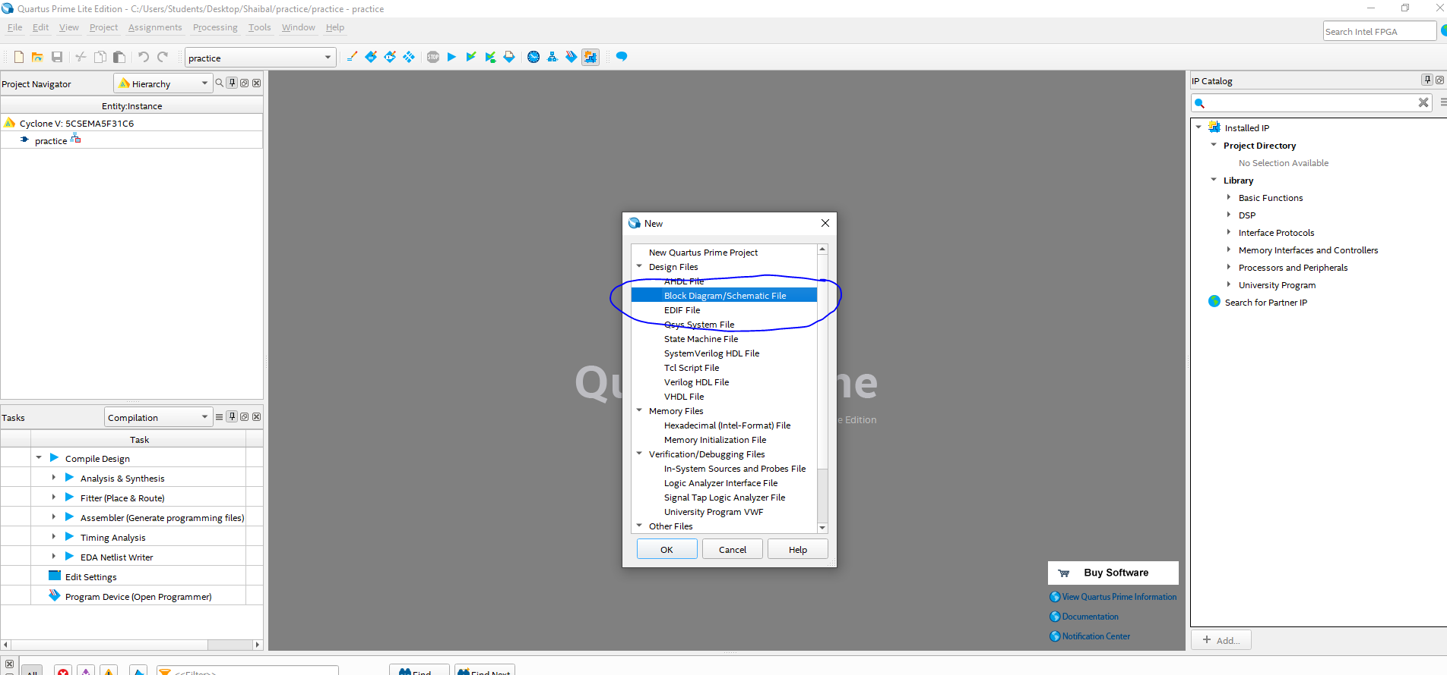

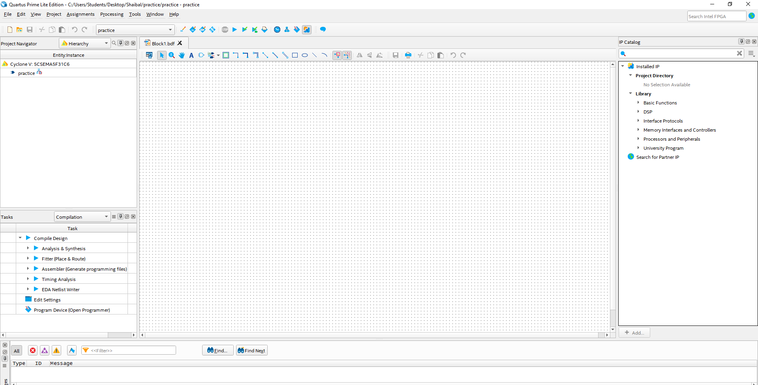

After the previous Window is appear Right click on your mouse and select insert and select symbol
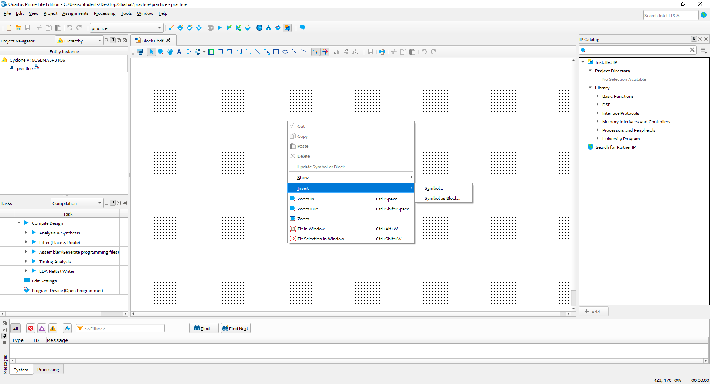

Go to Library and select which types of gates you need to draw. For example I am testing with AND gate 2 input .So I select primitive folder and select and2. See the screenshot

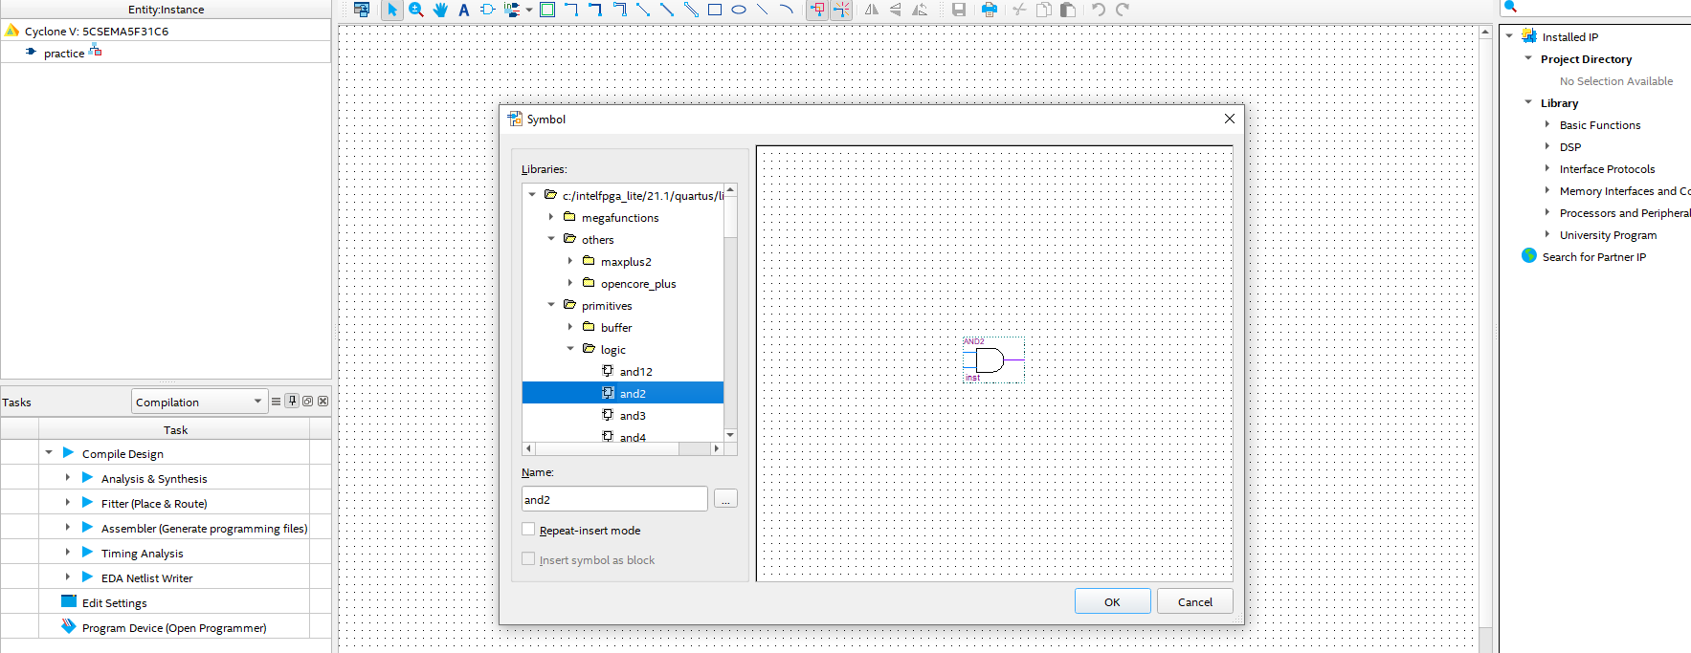

For input pin select pin->input, you can rename your pin name also just clicking on the pin. See the next screenshots
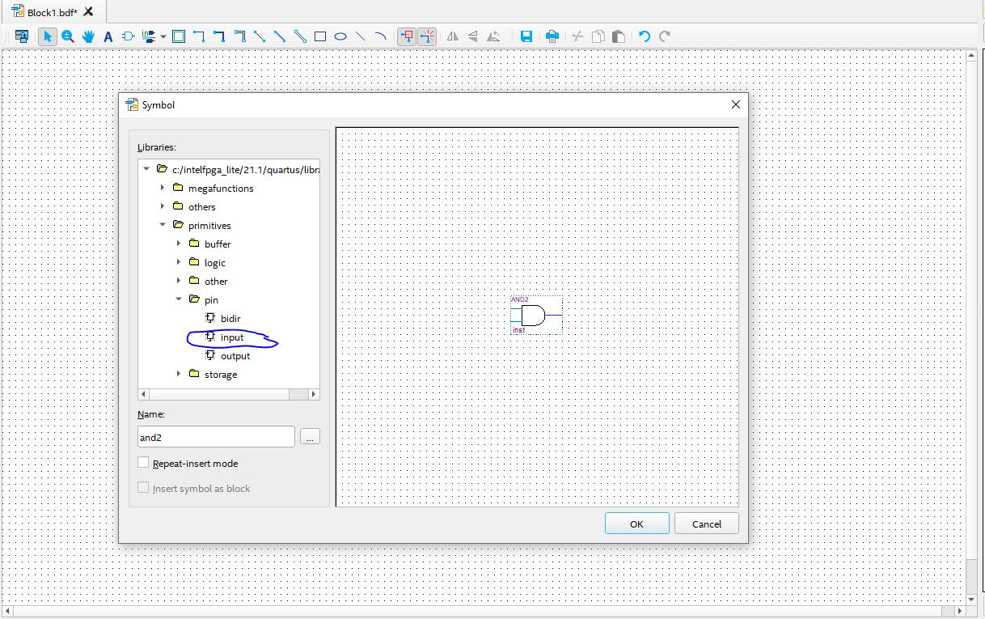

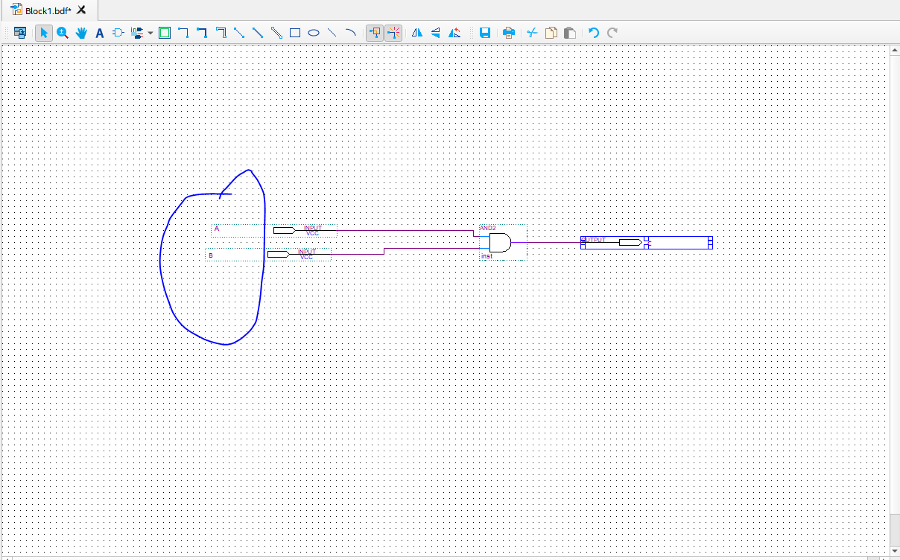

Select Run
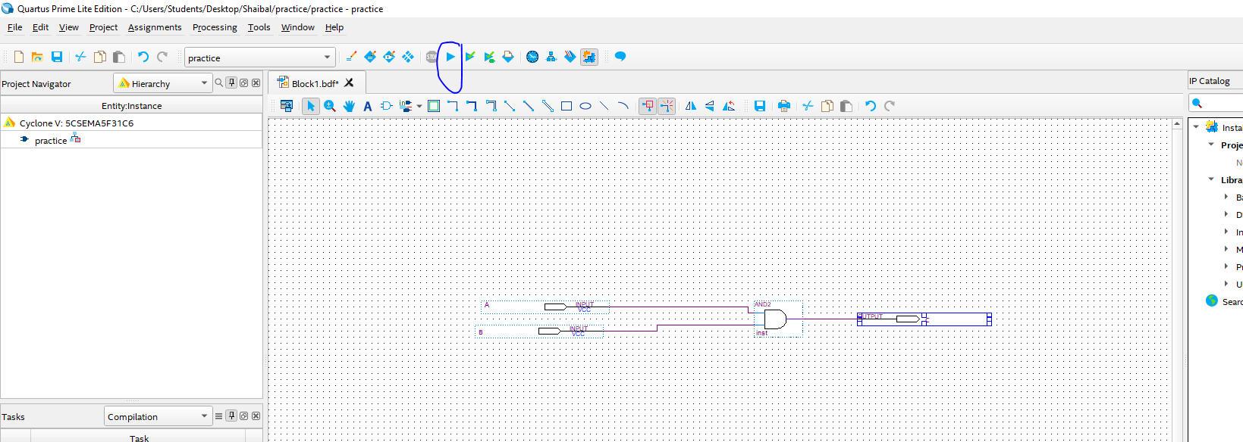

After successful running , the steps are similar what we did before with VHDL code in the to show it in the FPGA board. Successfully build screen


